Information for drivers of freight vehicles registered in a foreign country

Freight vehicles registered in a foreign country shall move through the territory of Georgia with following conditions:
- After completing the procedures at the customs checkpoint, means of transport shall move non-stop to a final destination. Stopping allowed only on specially designated areas - STOP POINTs, places for purchasing compulsory civil liability insurance policy (https://www.tpl.ge/en/salespoints), and parking lots located in the vicinity of customs checkpoint;
- Specially designated STOP POINT areas will serve for trucks for refueling, paying the road fee, compulsory civil liability insurance policy of the owner of a motor vehicle registered in foreign countries. Availability to purchase personal necessities, food, WC and etc.
- In case of emergencies/ special needs (car accident, health problems, etc.), the driver should contact the relevant services and should remain in the cabin of truck before the representatives of those services will get to the driver. For these purposes driver shall call the Emergency and Operative Response Center at 112;
- The truck should leave the territory of Georgia:
- In case of transit movement (except for the movements from/to customs check point "Kazbegi" ) transport means shall leave the territory of Georgia within 24 hours since entering the country;
- In case of transit via customs checkpoint "Kazbegi" - within 48 hours.
- In other cases of movement of freight vehicles operated by foreign nationals – within 48 hours from entering the country; and within 7 (seven) calendar days from entering the country in cases when after unloading of the imported goods the freight vehicle is loaded for further purposes of export from Georgia or if entering and/or leaving the territory of Georgia is carried out using the ferry crossing;

- The time periods required for carrying out the customs formalities and stopping at parking lots located in the vicinity of Georgian State Customs Border Crossing Point shall not be counted.
- It is strongly recommended to make only non-cash payment (online purchase, plastic card, etc.) and to use the personal protective equipment (medical mask, gloves, and etc).

Note:
- STOP POINT located at:
- Urbnisi– Kareli districts, cadastral code: 68.16.45.054;
- Terjola– Trejola district, village Siktarva, cadastral code : 33.08.38.224;
- Gori – Gori district, village Tiniskhidi, cadastral code: 66.44.02.033;
- Zestaponi – Zestapoini district, village Argveta, cadastral code: 32.03.34.211.
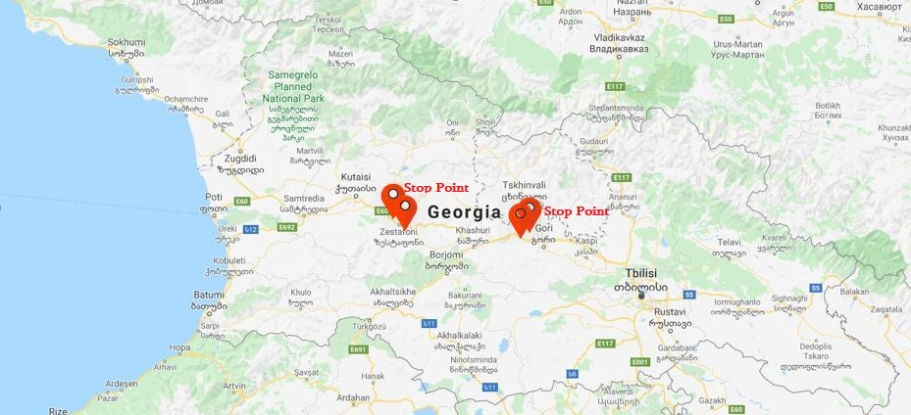
- Violation of rules (vehicle without permission to leave, stopping in forbidden areas, violation of terms of movement, etc.), except when weather conditions or other external factors makes it difficult and / or impossible to follow rules, the vehicle driver will be fined with 3000 GEL for the violation of the State emergency regime in accordance with Presidential Decree №1 March 21, 2020, Article 8, and will be placed in 14-day quarantine, means of transport will be taken to the impound lot.

